

# Gandhi RO Turnkey Project

In its commitment to advancing healthcare and providing state-of-the-art facilities, Gandhi Hospital is embarking on a groundbreaking initiative to establish dedicated Liver and Kidney Transplant Centers. These centers will not only facilitate life-saving transplant surgeries but also incorporate cutting-edge features, including isolation rooms and intensive care units (ICUs). To ensure the utmost care for patients, the hospital has proposed the installation of a sophisticated Reverse Osmosis (RO) plant, specifically designed to meet the dialysis requirements of patients admitted to the ICUs.

Recognizing the importance of renal care for transplant patients, it is proposed to setup a double pass RO plant with a recirculation loop. This innovative approach is tailored to meet the dialysis requirements of patients admitted to the ICUs. Dialysis is a vital component of post-transplant care, especially for patients with compromised kidney function.

A double pass RO system involves the water passing through the RO membrane twice, ensuring a higher level of purity. This is particularly important for dialysis, where water quality directly impacts the effectiveness of the treatment. The recirculation loop enhances efficiency by allowing for the reuse of treated water, minimizing stagnation, dead ends and ensuring a continuous supply of purified water for dialysis procedures.

Benefits of Double Pass RO with Recirculation Loop:

1. Enhanced Purity: The double pass RO system ensures that the water used for dialysis is of the highest purity, meeting stringent healthcare standards. This is crucial for preventing complications in transplant patients with compromised immune systems.
2. Efficiency and Sustainability: The recirculation loop minimizes water wastage by allowing for the reuse of treated water. This not only contributes to the hospital's environmental sustainability efforts but also ensures a continuous and reliable supply of purified water for dialysis procedures.
3. Reduced Operating Costs: While the initial setup of a double pass RO system may involve a higher investment, the long-term benefits include lower operating costs due to increased efficiency.
4. Minimized Infection Risk: The advanced water treatment provided by the double pass RO system significantly reduces the risk of infections related to dialysis. This is of paramount importance for transplant patients who are already susceptible to post-operative complications.

Registered Office: # 301, Vaishnavi Meadows, Indira Nagar, Telephone Colony Main Road, Kothapet Hyderabad – 500035 || Telangana || India

Sales Office: H. No. 3-14-49/111, Road No. 6, Subhodaya Colony, Mansoorabad, Vanasthalipuram Hyderabad – 500070 || Telangana || India

Email: [ananyamedisys@gmail.com](mailto:ananyamedisys@gmail.com) || Mobile: +91 9177774517

Page **2** of **5**

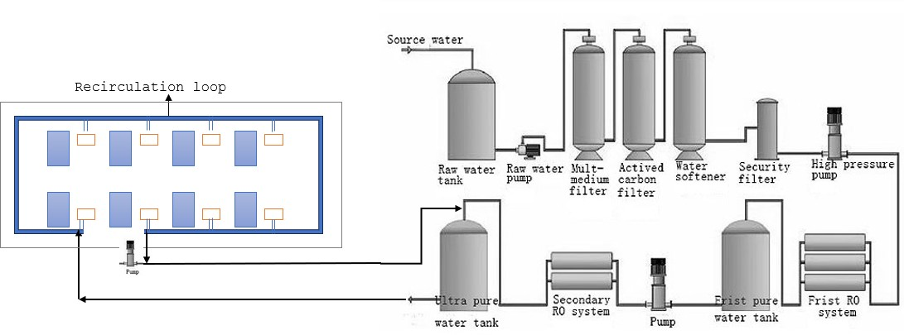* Water softener will be deployed only if required based on water report

|  |  |
| --- | --- |
| **FEED PUMP** |  |
| **Numbers Offered** | Two |
| **Max.Flow** | 9000 Liters Per hour |
| **H.P** | 1.5 hp |
| **Make** | CNP/LEO/LUBI |
|  |  |
| **RAW Water Tank** | 5000 liter plastic tank |
|  |  |
| **SAND FILTER** |  |
| **Height on Straight** | 1665 mm |
| **Unit Diameter** | 325 mm |
| **Filter Media Quartz** | Quartz Sand |
| **Frontal Pipe work** | MULTIPORT VALVE WITH ¾ SS LINES |
| **Material of Construction** | SS Vessel |
| **QUANTITY** | 100 Kgs |
|  |  |
| **ACTIVATED CARBON FILTER** |  |
| **Height on Straight** | 1665 mm |
| **Filter Media** | Activated Carbon (IV – 600 ) |
| **Frontal Pipe work** | MULTIPORT VALVE WITH 1 INCH SS LINES |
| **Material of Construction** | SS VESSEL |
| **QUANTITY** | 50KGS |

As per the two proposals submitted earlier on turnkey basis, one based on FRP and another based on Stainless steel usage in RO room. The cost break-up for the same is as follows:

# EQUIPMENT TECHNICAL SPECIFICATIONS IN DETAIL:

Page **3** of **5**

|  |  |  |
| --- | --- | --- |
|  |  | |
|  |  |  |
|  | **ANTISCALANT DOSING SYSTEM** |  |
| **Dosing Pump** | 1 No’s (On-Line) |
| **Capacity** | Max 6 LPH |
| **Make** | I-Dose |
|  | |
| **RO Membrane** | 4 No’s |
| **Membrane Type** | Spiral wound |
| **Membrane Size** | 8” dia X 1 Meter Length |
| **Membrane Specification** | Thin Film Composite Polyamide |
| **Membrane Make :** | G.E. OSMONICS (or) HYDRAUNAUTICS |
|  |  |
| **Membrane housing** | 2 Nos – UKL/Alpha - SS Housings |
| **Size** | 8 Inch Dia X 7.5 Feet Length |
|  |  |
| **High Pressure Pump** | 3000 LPH. Make pump with SS Impellers & |
| **In-let/Out-let Port.** | LEO/CNP/LUBI |
|  |  |
| **No. of High Pressure Pumps** | 2 No |
| **Motor HP / KW** | 4 HP –3 Phase/3 KW. |
|  |  |
| **Instrumentations:** |  |
| **Pressure gauges** | 4 NO.S |
| **TYPE** | GLIZERINE |
| **Rota meters** | 4 NO.S |
| **MOC** | PVC |
| **R.O. SKID** | 02 NO.S |
| **MOC:** | SS 202 |
| **Thickness:** | 1.0 MM |
| **CONTROL PANEL WITH CONDUCTIVITY** | 2 NO.S |
|  |  |
| **MICRON FILTER** | 4 NO.S |
| **Moc** | HDPE |
| **Length** | 20 INCHES. |
|  |  |
| **U.V.SYSTEMS** | 4 no.s |
| **MOC** | Stainless Steel.. |
| **Service Flow** | 1,000 Liters per Hour |
| **Make .** | Alfa |
| **Thickness** | 1 MM |
| **Length** | 1 Meter |
| **Dia** | 3 INCHES |
| **Location** | Before Sand Filter & After S.S.Tank Out-Let. |
|  |  |
| **L.P and H.P Switches** | 4 Set |



Given below is the typical monthly preventive maintenance check list:

Page **4** of **5**

|  |
| --- |
| A Typical RO PM Checklist: |
| · Test RO feed water TDS, and water hardness content |
| · Log RO pump pressure, flow rate |
| · Test RO product water TDS and log flow rates |
| · Test RO reject water TDS and log flow rates |
| · Log Recovery % |
| · Log Rejection % |
| · Log pressure gauge readings. Change RO pre-filters |
| · Check salt/ chemical tank levels and add as needed. Repair any minor leaks. Update PM Logs |

# Maintenance schedule:

|  |  |  |  |
| --- | --- | --- | --- |
|  | **Multimedia Filter** |  |  |
|  | Maintenance: | Frequency: | Recommendation |
| **1** | Check Pressure Drop | Every visit | Monthly |
| **2** | Back wash filter / Rinse for 10  minutes | as needed | **Daily\*\*** |
|  |  |  |  |
|  | **Carbon Filter** |  |  |
|  | Maintenance: | Frequency: |  |
| **3** | Back wash filter / Rinse for 10  minutes | as needed | **Daily\*\*** |
|  | **Water Softener** |  |  |
|  | Maintenance: | Frequency: |  |
| **4** | Check Hardness | every visit | Monthly |
| **5** | Fill Brine Tank | as needed |  |
| **6** | Regenerate Softener | as needed | **Based on OBR (Output between Regeneration)\*\*** |
|  |  |  |  |
|  | **Micron Cartridge Pre-Filters** |  |  |
| **7** | Check Pressure Drop | every visit | Monthly change |
| **8** | Log and replace cartridges as  needed | as needed |  |
|  |  |  |  |
|  | **Anti Scaling Dosing Pump** |  |  |
|  | Maintenance: | Frequency: |  |
| **9** | Log Chemical level | every visit | **Daily (depends on running hours of RO)\*\*** |
| **10** | Log Chemical addition | every visit | **Daily (depends on running hours of**  **RO)\*\*** |
| **11** | Repair/rebuild chemical pump | as needed |  |
|  |  |  |  |
|  | **Reverse Osmosis Unit** |  |  |



**daily maintenance or as needed tasks to be done by the hospital technical staff

|  |  |  |  |  |
| --- | --- | --- | --- | --- |
|  |  | | | |
|  |  | Maintenance: | Frequency: |  |
|  | **12** | Log Product water profile* | every visit | Monthly |
| **13** | Log Feed profile* | every visit |  |
| **14** | Log Brine profile* | every visit |  |
| **15** | Log Inspection Report | every visit |  |
| **16** | Log and Report Action Alerts | every visit |  |
|  | (Profile: TDS, pH, Temperature, Pressure, Hardness, Rejections  Rate, Recovery Rate, etc) |  |  |
|  |  |  |  |
|  | **Ultraviolet Sterilizers** |  |  |
|  | Maintenance: | Frequency: |  |
| **17** | Replace UV Lamps | as needed |  |
| **18** | Micro-bio testing, giving the  time and date |  | if required, done by external labs at  extra cost |
|  |  |  |  |
|  | **Sub Micron Cartridge Filters** |  |  |
|  | Maintenance: | Frequency: |  |
| **19** | Check Pressure Drop | every visit |  |
| **20** | Log and replace cartridges as  needed | as needed | Qtrly Change |

# Common spares required:

Page **5** of **5**

Pumps are the most likely failure points due to voltage fluctuations; it is highly recommended to have a standby pump for Raw water pump, High pressure pump, anti-scalant pump and booster pump. As any failure in any of the pumps can stall the RO and effect the functioning of the equipment in ICU. Typical repair times for pumps ranges from 3 days to 10 days.

**Plumbing:** Plumbing will be concealed with required no. of inlet points, the RO line will be at a height of 15” from FFL (Finished Floor Level) with 3/4th inch dia. Drain pipe will be at height of 4” to 6” typically at or above skirting level with a slight downward gradient. RO Line will be done with cPVC material with the least possible joints. Drain line will be done with normal PVC material.

**RO Shed:** Roofing sheets will be used for roof as well as walls with required supporting structures in steel to withstand normal weather conditions. The shed will be secured with a door with no gaps on all sides at floor level to prevent rodents entering the RO room. RO Shed will be set up in 15’ x 30’ space on terrace.